ITU - Poverty Unit
Bryan Andersen & Tresa Conboy

Central Focus:

Enduring Understandings:
- Students will understand the plight of those in poverty during the Great Depression, into the modern day.
- Students will understand the impact of the Great Depression socially and economically.
- Students will understand the impact of the New Deal on America.

Essential Questions:
- How was poverty handled during the Great Depression?
- How is poverty dealt with in modern day America?
- How did the government react to the Great Depression?
- How involved should the government be in working to eradicate poverty in America?

Calendar:
 | Day 1 / Hour 1 | Day 2 / Hour 2 | Day 3 / Hour 3 | Day 4 / Hour 4
ELD Standard | 6. Reading/viewing closely a. Explain ideas, phenomena, processes, and relationships within and across texts (e.g., compare/contrast, cause/effect, themes, evidence-based argument) based on close reading of a variety of grade-level texts, presented in various print and multimedia formats, using a variety of detailed sentences and precise general academic and domain-specific words. | 6. Reading/viewing closely a. Explain ideas, phenomena, processes, and relationships within and across texts (e.g., compare/contrast, cause/effect, themes, evidence-based argument) based on close reading of a variety of grade-level texts, presented in various print and multimedia formats, using a variety of detailed sentences and precise general academic and domain-specific words. | 9. Presenting Plan and deliver a variety of oral presentations and reports on grade-appropriate topics that express complex and abstract ideas, well supported by evidence and reasoning, and are delivered by using an appropriate level of formality and understanding of register. | 10b. Write clear and coherent summaries of texts and experiences by using complete and concise sentences and key words (e.g., from notes or graphic organizers).
Content Standard | 11.6.4 - Analyze the effects of and the controversies arising from New Deal economic policies and the expanded role of the federal government in society and the economy since the 1930s (e.g., Works Progress Administration, Social Security, National Labor Relations Board, farm programs, regional development policies, and energy development projects such as the Tennessee Valley Authority, California Central Valley Project, and Bonneville Dam). | 11.6.3 - Discuss the human toll of the Depression, natural disasters, and unwise agricultural practices and their effects on the depopulation of rural regions and on political movements of the left and right, with particular attention to the Dust Bowl refugees and their social and economic impacts in California  CCSS.ELA-LITERACY.RL.11-12.2  Determine two or more themes or central ideas of a text and analyze their development over the course of the text, including how they interact and build on one another to produce a complex account; provide an objective summary of the text. |  | CCSS.ELA-LITERACY.W.11-12.3  Write narratives to develop real or imagined experiences or events using effective technique, well-chosen details, and well-structured event sequences.
Objectives | 1. Upon completion of a powerpoint presentation and vocabulary activity, SWBAT properly explain and discuss the cause of the Great Depression and the response of the federal government during the 1930’s. | 1. After analyzing photos and excerpts of readings on the Great Depression, SWBAT evaluate the human toll and lasting impacts of the Great Depression and the Dust Bowl. | 1. After working in a group and completing a presentation, SWBAT compare and contrast the varying levels of poverty in the modern day, as well as draw comparisons to poverty during the Great Depression. | 1. SWBAT produce a 3-4 paragraph writing sample that thoroughly explains the federal role in both 1930’s America and modern day America, as well as compares and contrasts federal social and economic policies in regards to poverty.
Assessments | 1. The students will turn in a vocabulary chart as a formative assessment. | 1. The student groups will complete and turn in a graphic organizer that outlines their analysis of the photos. | 1. Students will work in teams of 4 to produce a presentation that covers the topic of poverty. | 1. Students will produce a 3-4 paragraph writing sample that correctly addresses the prompt.
Student Activities | 1. The students will take notes on a Powerpoint presentation that covers the historical background of the Great Depression.  2. The students will work in pairs to complete a vocabulary assignment to help reiterate the foundational knowledge. The students will complete a vocabulary chart that asks them to provide the definition, a sentence, and a picture/symbol for each word. | 1. The students will work in teams of four to analyze a photograph from the Great Depression. | 1. The students will work in groups to research information about modern poverty. The student groups will be assigned one of the following topics:  - Poverty Worldwide  - Poverty in the US  - Statewide Poverty  - Countywide Poverty  The student groups will complete their research and prepare a presentation in their choice format (video, poster, etc.) and present it to the class. | 1. The students will complete a quick write up based on their experience of distributing the care packages to the needy.
Service | The food/basic necessities drive will be introduced to the students. The teacher will explain the importance of helping out those in need, giving back to the community, and how they can help those living in poverty. | The students will bring in canned / dry good foods, as well as basic life necessities including socks, toothbrushes, deodorant, toothpaste, soap, etc. | The students will prepare care packages equipped with the food and basic necessities that they have collected. | The students will take the packages to a local homeless shelter or a local charity location to distribute them.

Rubric:

 | Exceeds | Meets | Approaching
b. Write clear and coherent summaries of texts and experiences by using complete and concise sentences and keywords (e.g., from notes or graphic organizers). | Paragraph is thoroughly complete and cohesive, heavily uses both texts and experiences to summarize, with complete sentences, domain-specific vocabulary, and appropriate register. | Paragraph is clear and cohesive, uses both texts and experiences to summarize with complete sentences and some domain-specific vocabulary. | Paragraph is somewhat clear and cohesive, uses experiences to summarize. Lacks complete sentences, appropriate register, and domain-specific vocabulary.
11.6.4 - Analyze the effects of and the controversies arising from New Deal economic policies and the expanded role of the federal government in society and the economy since the 1930s (e.g., Works Progress Administration, Social Security, National Labor Relations Board, farm programs, regional development policies, and energy development projects such as the Tennessee Valley Authority, California Central Valley Project, and Bonneville Dam). | Paragraph thoroughly and accurately compares and contrasts the federal social and economic policies during the Great Depression and the federal social and economic policies in the modern day, using an abundance of domain-specific vocabulary and appropriate register. | Paragraph accurately compares and contrasts the federal social and economic policies during the Great Depression and the federal social and economic policies in the modern day, using domain-specific vocabulary and appropriate register. | Paragraph attempts to compare and contrast the federal social and economic policies during the Great Depression and the federal social and economic policies in the modern day, using some domain-specific vocabulary and lacks appropriate register.

Vocabulary Terms:

Word | Definition | Sentence | Picture/Symbol

Bull Market

Bear Market

Buying on Margin

Black Thursday

Black Tuesday

Breadlines

Shantytowns

Franklin D. Roosevelt

New Deal

Civilian Conservation Corps

National Industrial Recovery Act

Agricultural Adjustment Administration

Tennessee Valley Authority

Share Our Wealth Works Program

Social Security Act

Wagner Connery Act

Congress Industrial Organizations

Dust Bowl

Federal Project Number One

Group Photo Analysis

 | What do you see? | What do you think? | What do you know? | What do you wonder?
Photo #1
Photo #2
Photo #3

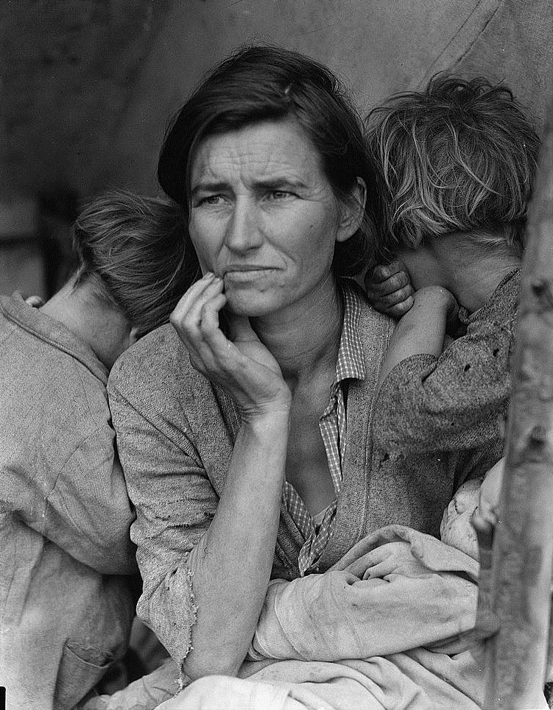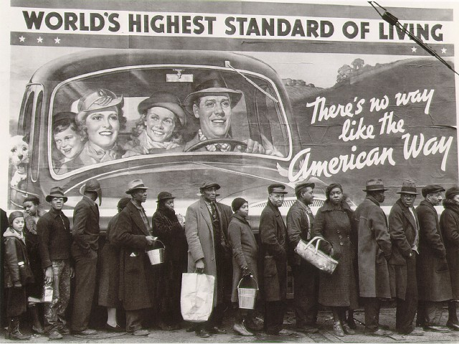
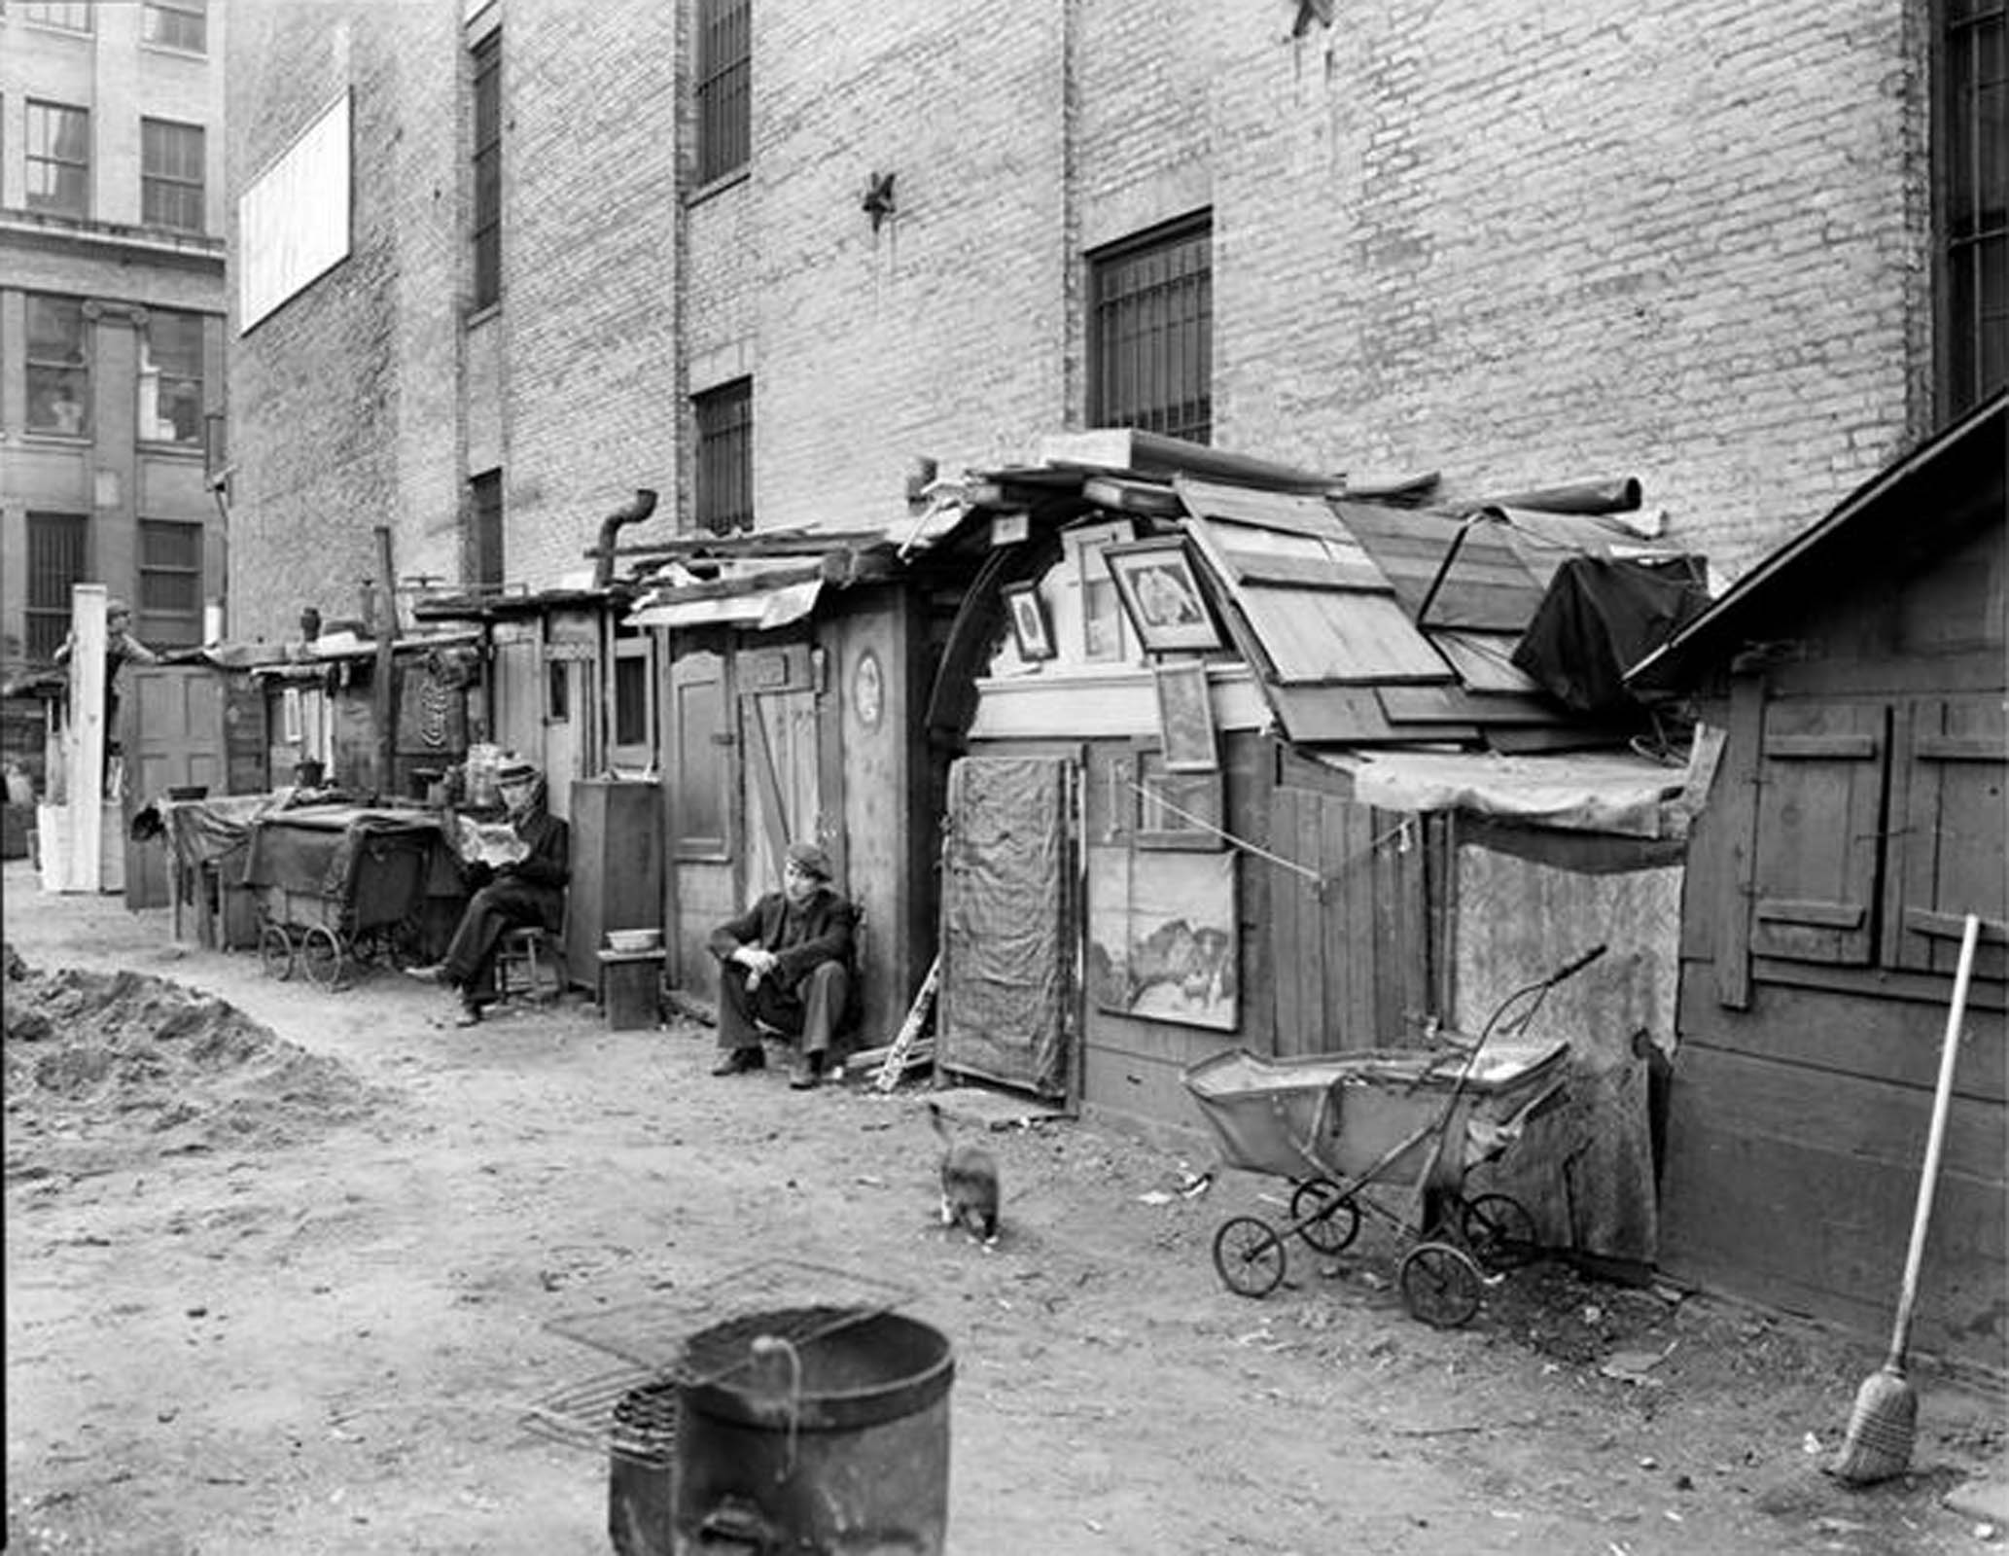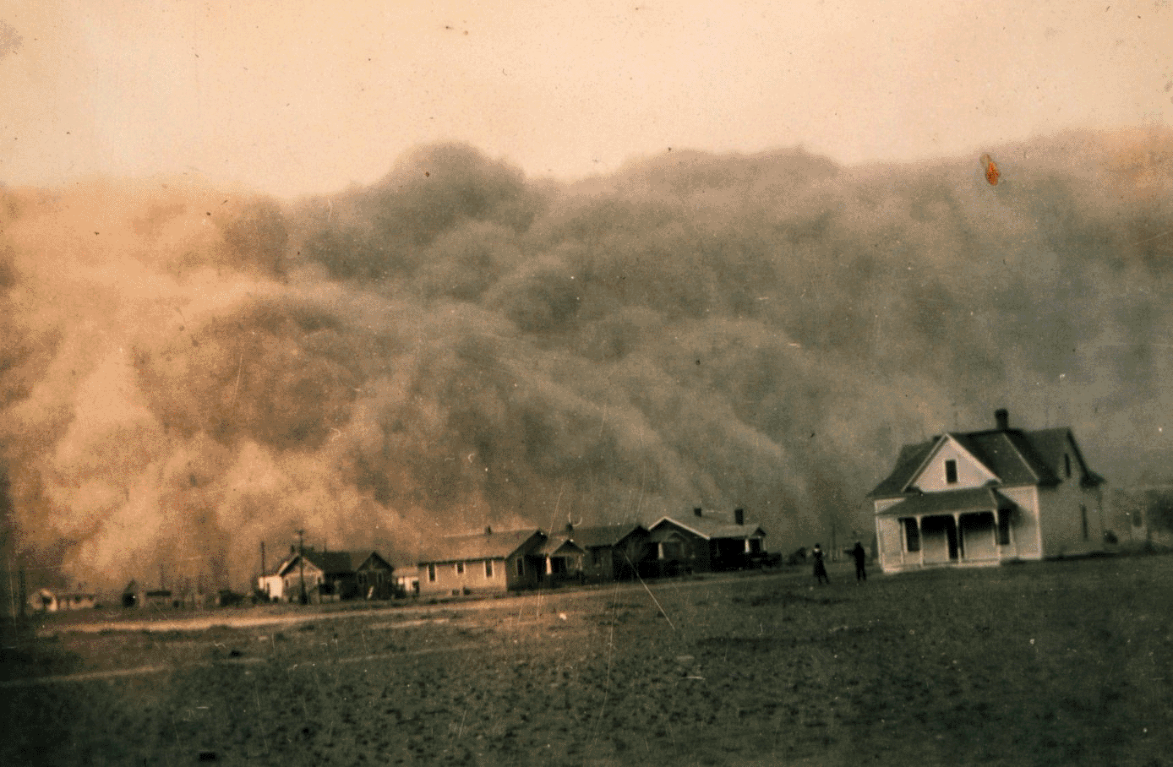
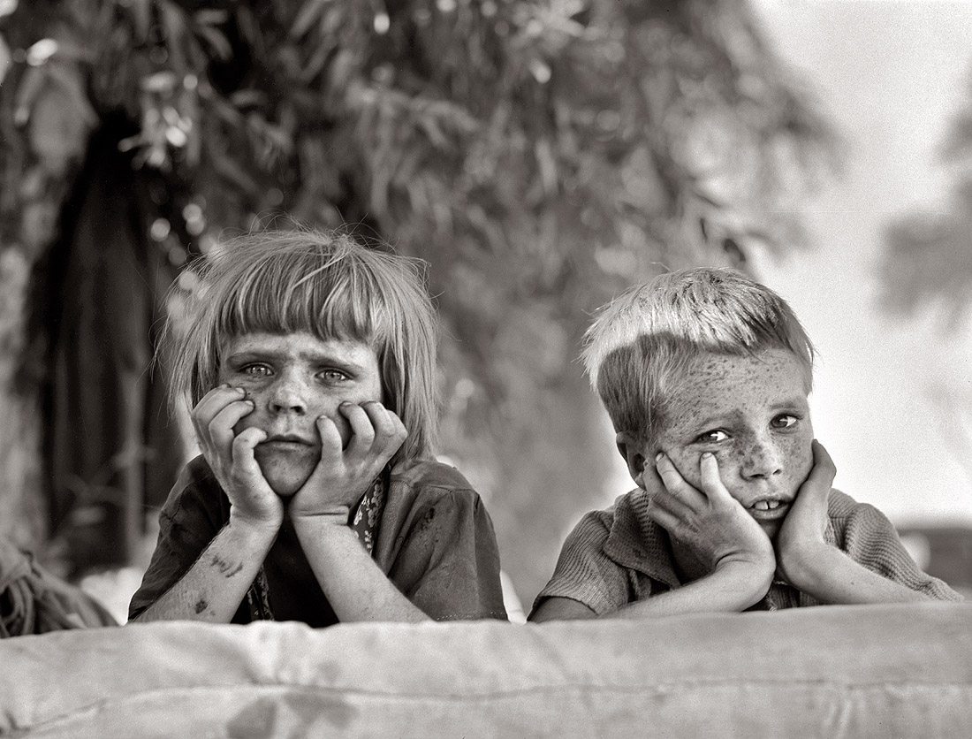
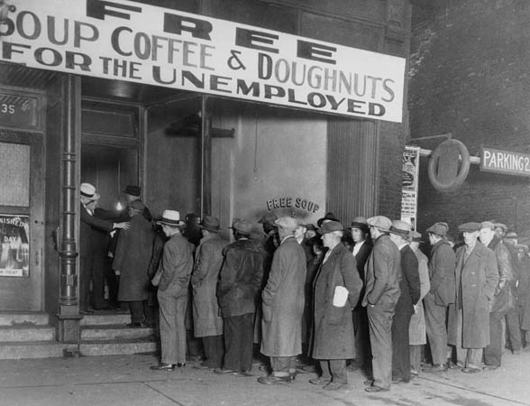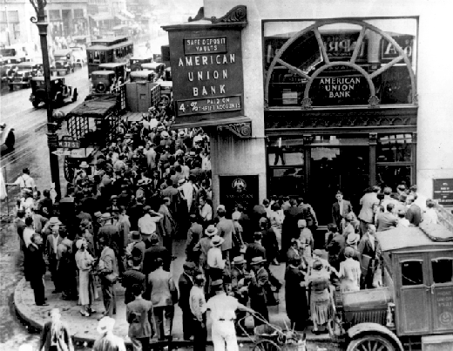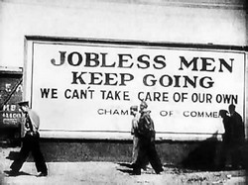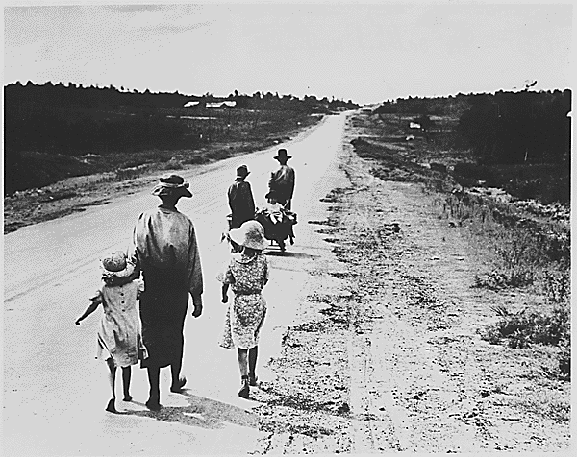

Cooperative Learning Roles & Materials: Day 3 / Hour 3 Activity
Activity Instructions:
Students will work in groups of four-five to research information about modern poverty. The student groups will be assigned one of the following topics:
- Poverty Worldwide
- Poverty in the US
- Statewide Poverty
- Countywide Poverty
The student groups will complete their research and prepare a presentation in their choice format (video, poster, etc.) and present it to the class. Once all presentations have been presented, the students will work to compare the different levels of modern poverty with the Great Depression, focusing on:
- demographics
- location (urban, suburban, etc.)
- government interference

Group Roles:
- Head Researcher - The researcher will head the research aspect of the assignment, tracking down key information needed to answer the required questions.
- Secretary - The secretary will record and write out key information provided by the researcher. The secretary will complete the write-up aspect of the assignment.
- Graphic Designer - The graphic designer will head the presentation in whatever format they choose. The designer will type in the information, add visuals, and any other items needed for their presentation.
- Spokesperson - This person(s) will be responsible for presenting the presentation.

Materials:

Student Instructions:
In your group of three or four, collaborate to complete a brief presentation in a medium of your choice (prezi, powerpoint, paper, etc.) on your assigned topic. Decide amongst yourselves who take on what role:
- Head Researcher - The researcher will head the research aspect of the assignment, tracking down key information needed to answer the required questions.
- Secretary - The secretary will record and write out key information provided by the researcher. The secretary will complete the write-up aspect of the assignment.
- Graphic Designer - The graphic designer will head the presentation in whatever format they choose. The designer will type in the information, add visuals, and any other items needed for their presentation.
- Spokesperson - This person(s) will be responsible for presenting the presentation.
Your presentation must address the following:
- demographics (Who is living in poverty? Look at gender, age, ethnicity, etc.)
- location (Where is poverty most prevalent? Cities? Suburbs?)
- government interference / support (What is the government doing to help?)

Graphic Organizer:

Worldwide Poverty v Great Depression:

Similarities | Differences

Poverty in the modern United States v Great Depression:

Similarities | Differences

Poverty in modern California v Great Depression:

Similarities | Differences

Poverty in modern San Diego v Great Depression:

Similarities | Differences

